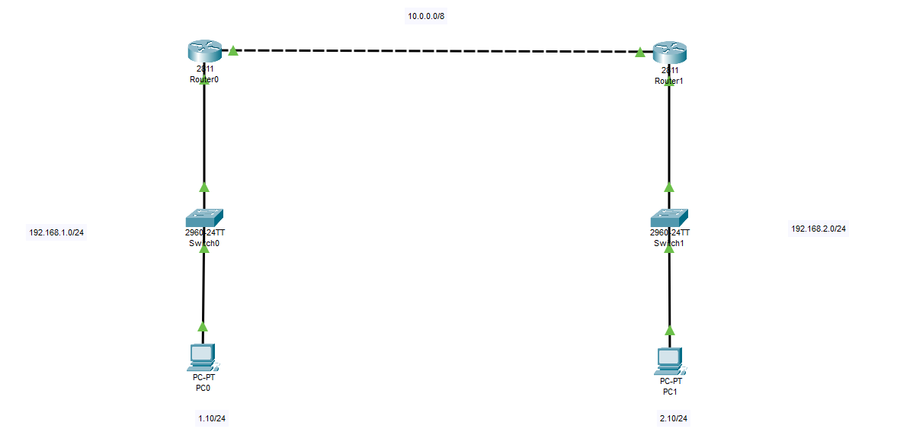**RIP configuration for Router R1 – interface FA0/0**

|  |
| --- |
| Router>en  Router#conf t  Enter configuration commands, one per line. End with CNTL/Z.  Router(config)#int fa0/0  Router(config-if)#ip add 192.168.1.1 255.255.255.0  Router(config-if)#no shut  Router(config-if)#  %LINK-5-CHANGED: Interface FastEthernet0/0, changed state to up  %LINEPROTO-5-UPDOWN: Line protocol on Interface FastEthernet0/0, changed state to up  ^Z  Router#  %SYS-5-CONFIG_I: Configured from console by console  Router#wr  Building configuration...  [OK]  Router# |

RIP configuration for Router R1 – interface 0/1

|  |
| --- |
| Router#en  Router#conf t  Enter configuration commands, one per line. End with CNTL/Z.  Router(config)#int fa0/1  Router(config-if)#ip add 10.0.0.1 255.0.0.0  Router(config-if)#no shut  Router(config-if)#  %LINK-5-CHANGED: Interface FastEthernet0/1, changed state to up  Router(config-if)#  Router#  %SYS-5-CONFIG_I: Configured from console by console  Router#wr  Building configuration...  [OK]  Router# |

**RIP configuration for Router R2 – interface FA0/0 & FA0/1**

|  |
| --- |
| Router>en  Router#conf t  Enter configuration commands, one per line. End with CNTL/Z.  Router(config)#int fa0/0  Router(config-if)#ip add 192.168.2.1 255.255.255.0  Router(config-if)#no shut  Router(config-if)#  %LINK-5-CHANGED: Interface FastEthernet0/0, changed state to up  %LINEPROTO-5-UPDOWN: Line protocol on Interface FastEthernet0/0, changed state to up  Router(config-if)#exit  Router(config)#int fa0/1  Router(config-if)#ip add 10.0.0.2 255.0.0.0  Router(config-if)#no shut  Router(config-if)#  %LINK-5-CHANGED: Interface FastEthernet0/1, changed state to up  %LINEPROTO-5-UPDOWN: Line protocol on Interface FastEthernet0/1, changed state to up  Router(config-if)#exit  Router(config)# |

**RIP Configurations on both R1 & R2 routers**

Go to Router R1

|  |
| --- |
| Router#conf t  Enter configuration commands, one per line. End with CNTL/Z.  Router(config)#router rip  Router(config-router)#*network 192.168.1.0*  Router(config-router)#*network 10.0.0.0*  Router(config-router)#^Z  Router#  %SYS-5-CONFIG_I: Configured from console by console  Router#wr  Building configuration...  [OK]  Router# |

Go to Router R2

|  |
| --- |
| Router(config)#  Router(config)#router rip  Router(config-router)#*network 192.168.2.0*  Router(config-router)#*network 10.0.0.0*  Router(config-router)#^Z  Router#  %SYS-5-CONFIG_I: Configured from console by console  Router#wr  Building configuration...  [OK]  Router# |